

**SAM4S Xplained Pro**

***Tutorial and Quick Startup Guide***

Table of Contents

List of Figures 2

Product Description 4

EVALUATION Kit Contens 4

DOCUMENTATION 5

SAM4SD32C 5

Atmel® SAM4S Xplained Pro 5

SOFTWARE INSTALLATION 6

Software Updates 8

USB Installation 10

QUICK START KIT DEMO 11

Demo Program 11

Modification to Demo Program 13

HARDWARE DEBUGGER 14

Break Point 14

Variable Watch 14

TERMINAL FOR ATMEL STUDIO 16

CODE EXERCISES 17

Swap Variables 17

Count Bits In Byte 18

Nth Bit Test 19

Extra Credit 20

# List of Figures

Figure 1 Evaluation Kit Contents 4

Figure 2 Quick Reference 5

Figure 3 Software Installation Error 6

Figure 4 Atmel USB Driver 7

Figure 5 Atmel Studio 8

Figure 6 Software Update 8

Figure 7 ASF Update 9

Figure 8 USB Drivers 10

Figure 9 Starter Kit Demo 11

Figure 10 SAM4S Xplained Pro 11

Figure 11 Starter Kit Demo 12

Figure 12 Update Debugger FW 13

Figure 13 Demo Application Modification 14

Figure 14 Add Watch Variable 15

Figure 15 Watch List 15

Figure 16 Atmel Terminal Window 16

Figure 17 Swap Function 17

Figure 18 Count Bits Set In Byte 18

Figure 19 Nth Bit Test 19

Figure 20 SHA256 20

# Product Description

The Atmel® SAM4S Xplained Pro is a fully integrated platform for the Atmel® SAM4S CortexTM M4 microcontroller. This evaluation kit has all the required hardware and software tools such as Atmel Studio, Atmel Software framework (ASF) drivers, and demonstration code to begin prototype development in minutes! Along with the microcontroller board, other peripheral boards such as a LCD, generic sensor and IO board and prototype board.

# EVALUATION Kit Contens

The Atmel® SAM4S Xplained Pro Evaluation Kit contains the following items listed in Figure 1.

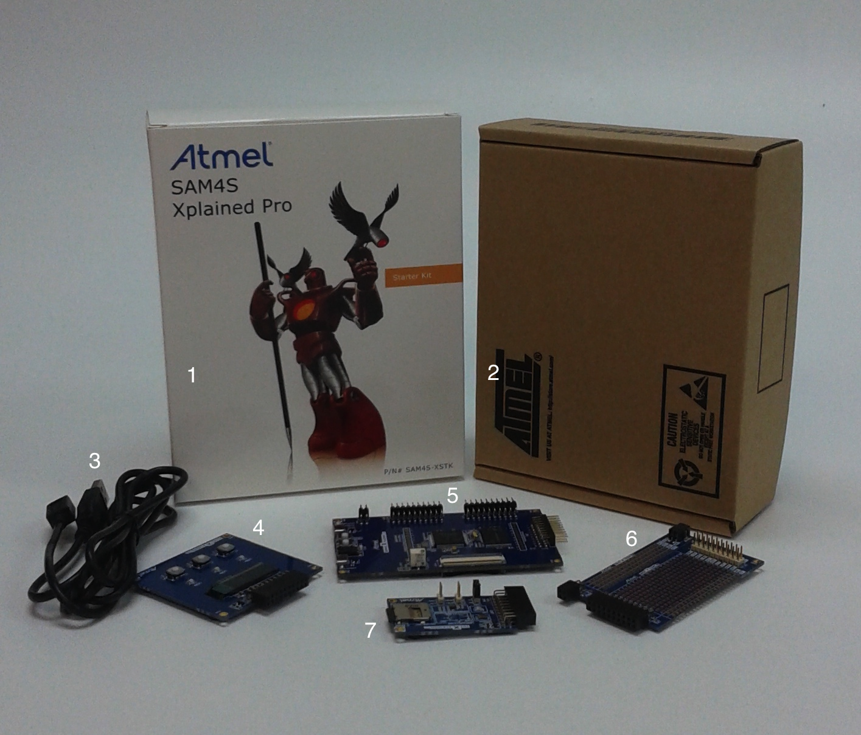

Figure Evaluation Kit Contents

|  |  |
| --- | --- |
| Item | Description |
| 1 | Kit Printed Outer Cover |
| 2 | Atmel Cardboard Box – No Label |
| 3 | Micro USB Cable to Type A Plug – x 2 |
| 4 | OLED1 Xplained Pro |
| 5 | Atmel® SAM4S Xplained Pro Evaluation Kit |
| 6 | Prototype Board |
| 7 | I/01 Xplained Pro |

Table List of Kit Contents

# DOCUMENTATION

## SAM4SD32C

1. The Atmel® SAM4S Xplained Pro uses the SAM4SD32C. Download the [SAM4S datasheet](http://www.atmel.com/Images/Atmel-11100-32-bit%20Cortex-M4-Microcontroller-SAM4S_Datasheet.pdf) for future reference.
2. Download any SAM4S [Application Notes](http://www.atmel.com/devices/sam4sd32c.aspx?tab=documents) as needed.

## Atmel® SAM4S Xplained Pro

1. Download [Atmel Embedded Debugger User Guide](http://www.atmel.com/Images/Atmel-42096-Microcontrollers-Embedded-Debugger_User-Guide.pdf).
2. Download [SAM4S-Xplained-Pro_User-Guide.pdf](http://www.atmel.com/Images/Atmel-42075-SAM4S-Xplained-Pro_User-Guide.pdf).
3. Download [SAM4S-Xplained-Pro_User-Guide.zip](http://www.atmel.com/images/Atmel-42075-SAM4S-Xplained-Pro_User-Guide.zip)

*Note: This zip file contains schematics and Gerber files for the Atmel® SAM4S Xplained Pro.*

1. Atmel® SAM 4S Xplained Pro Quick Reference

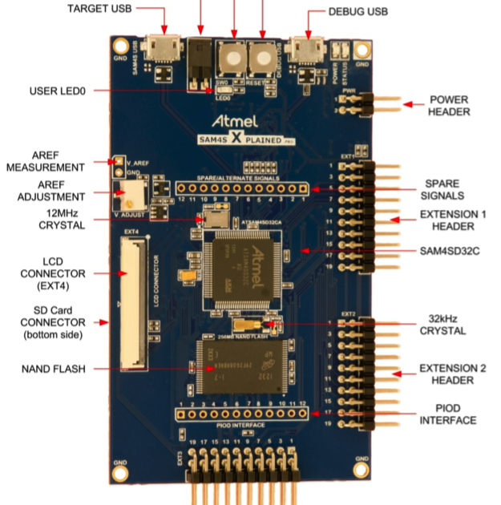

Figure Quick Reference

# SOFTWARE INSTALLATION

To use the Atmel® SAM4S Xplained Pro, several pieces of software need to be installed on a local machine. Please follow the instructions in the

1. Create a [myAtmel](https://secure.atmel.com/forms/Secure/user-registration.aspx?target_url=EN) account.

*Note: The myAtmel account is required for all software installations. Although the software is licensed free of charge, the registration is needed for future software and hardware upgrades as well as reporting any technical issues a user my encounter.*

1. Download the latest version of [Atmel Studio](http://www.atmel.com/tools/atmelstudio.aspx?tab=overview).

*Note: There are two versions of Atmel Studio available. The first installation is for users who have installed previous versions of Atmel Studio or have access the Internet on their target computer. This version is preferred for it’s a much smaller installation file. The second installation is the complete package and is required for stand-alone computers without Internet access.*

1. Download the latest [Atmel USB Driver](http://www.atmel.com/tools/atmelstudio.aspx?tab=overview).
2. Optional: Down the latest [Release Notes](http://www.atmel.com/Images/AStudio6_2sp2_1563-readme.pdf).
3. Click on the Atmel USB Driver that was downloaded in step 3.
4. Click on the Atmel Studio installation file that was downloaded in step 2.

*Note: You may encounter a message during the installation stating the software has not passed Windows Logo Testing. See* Figure 3*. Select the “Continue Anyway” button.*

*Note: You may encounter a message during the installation starting that there is an Atmel USB Driver pending. See* Figure 4*. Select Install.*

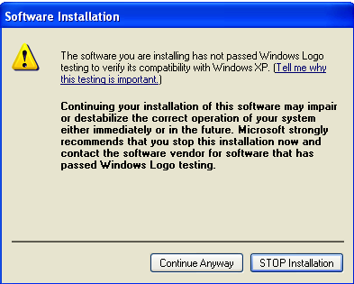

Figure Software Installation Error

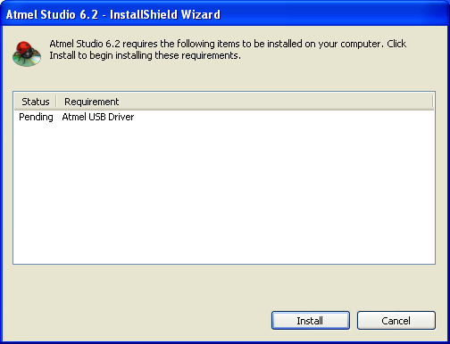

Figure Atmel USB Driver

## Software Updates

After the Atmel studio has been installed, there may minor updates to the software tool package. Please follow the Software Update Steps.

1. Lunch the Atmel Studio application



Figure Atmel Studio

1. When Atmel Studio is loaded, the software will check to see if the tool is running the latest version. If not, a dialog in a Software Update in Figure 6 will appear. Please select the Update button.

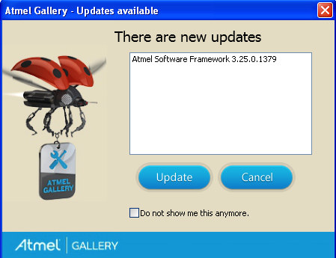

Figure Software Update

1. If there are updates, select the Updates record as shown in Figure 7. Then select the download button.

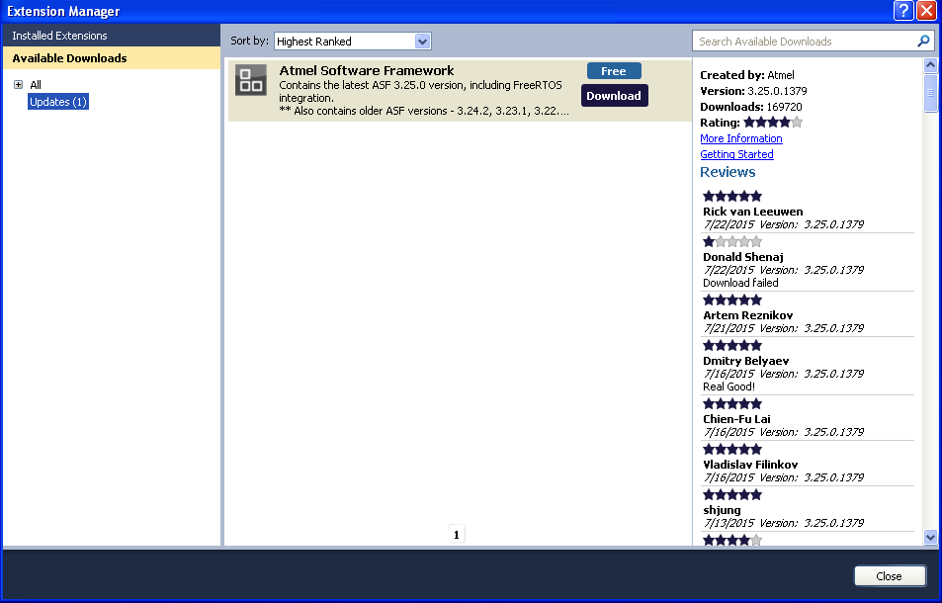

Figure ASF Update

1. Log in with your myAtmel Account and download the file.

*Note: You have the option of running the Atmel Software Framework update from the server. If you get an error, download the update to your hard drive.* **Close Atmel Studio** *and reinstall Atmel Software Framework update.*

## USB Installation

1. Connect the micro USB cable to your computer and the DEBUG USB port. See Figure 2 for reference.
2. The operating system will recognize the new hardware and request to install the driver.
3. Select *Install the software automatically*

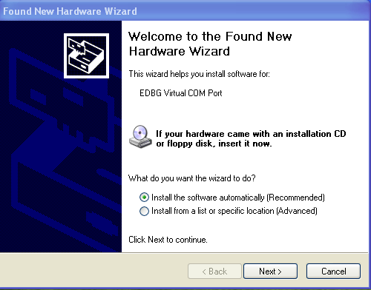

Figure USB Drivers

# QUICK START KIT DEMO

Once the required software has been installed, it is now possible to being using the Atmel® SAM4S Xplained Pro. There are several example programs that are specific to the Atmel® SAM4S Xplained Pro and have been load with Atmel Studio. To load a demonstration program, follow these steps:

## Demo Program

1. Plug the micro-USB cable into the Atmel® SAM4S Xplained Pro and into your computer. Please see Figure 9 for reference.

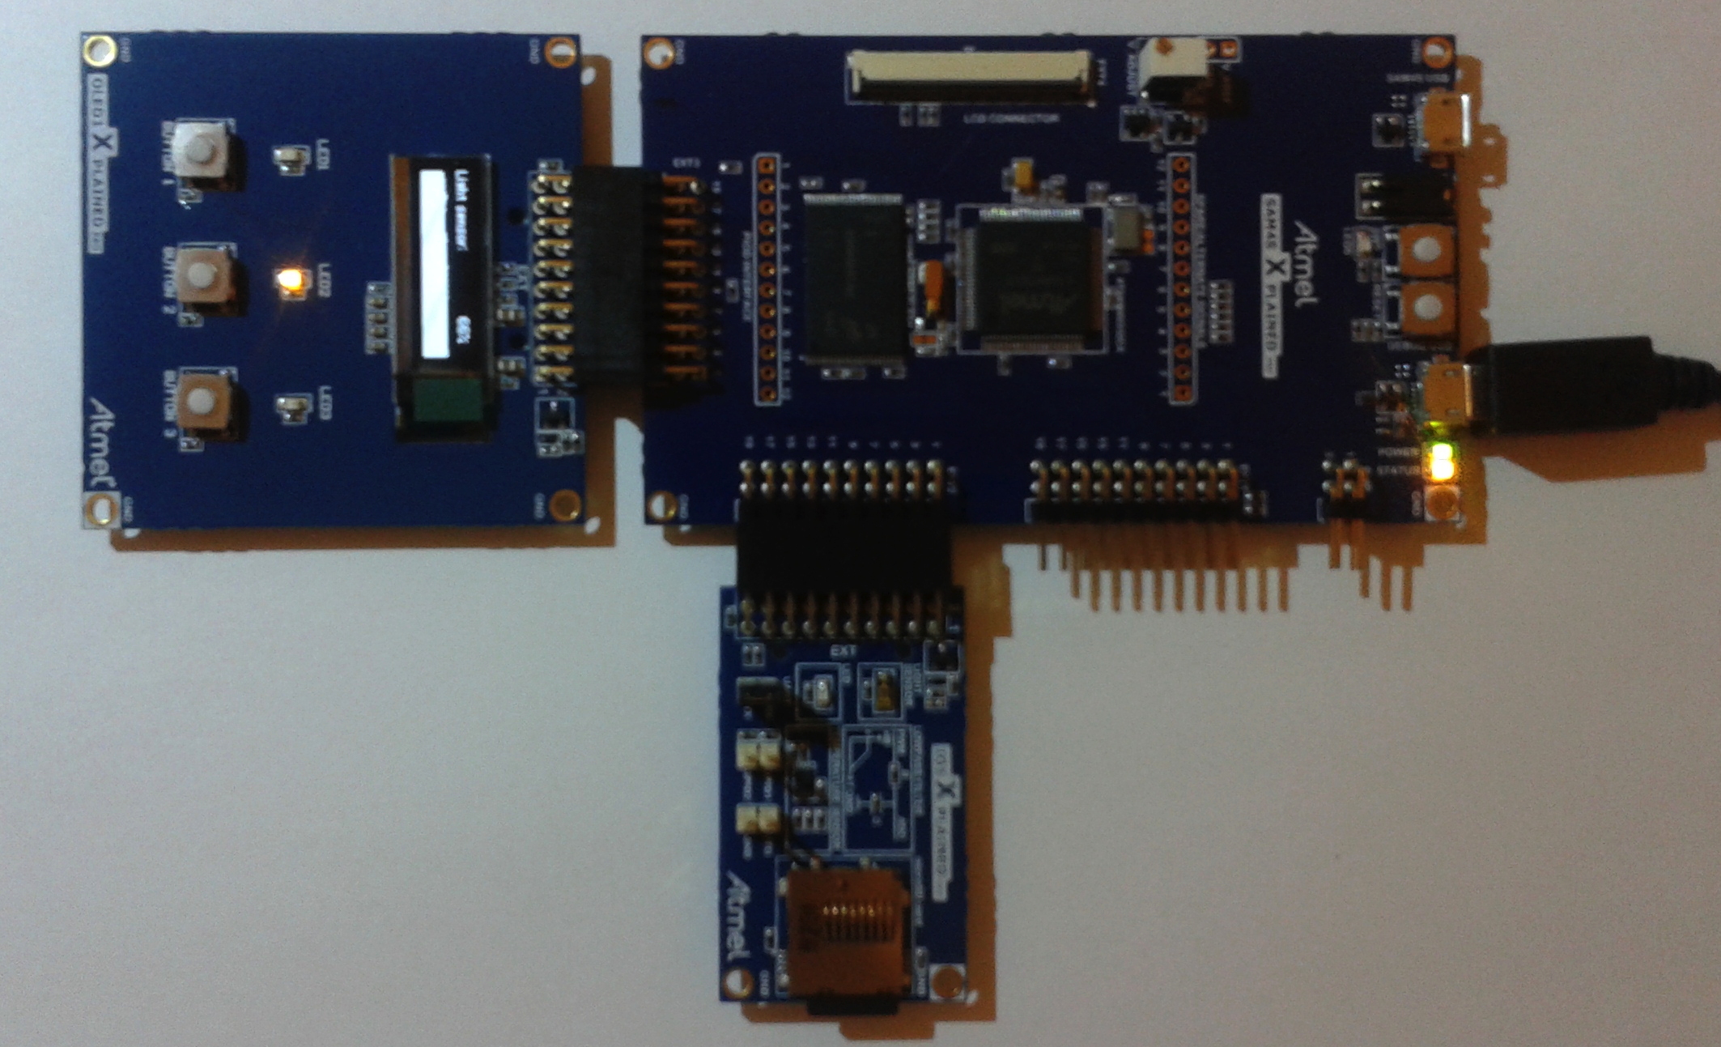

Figure Starter Kit Demo

1. Start Atmel Studio. The software will recognize the device has been connected to your computer and display the following splash screen.

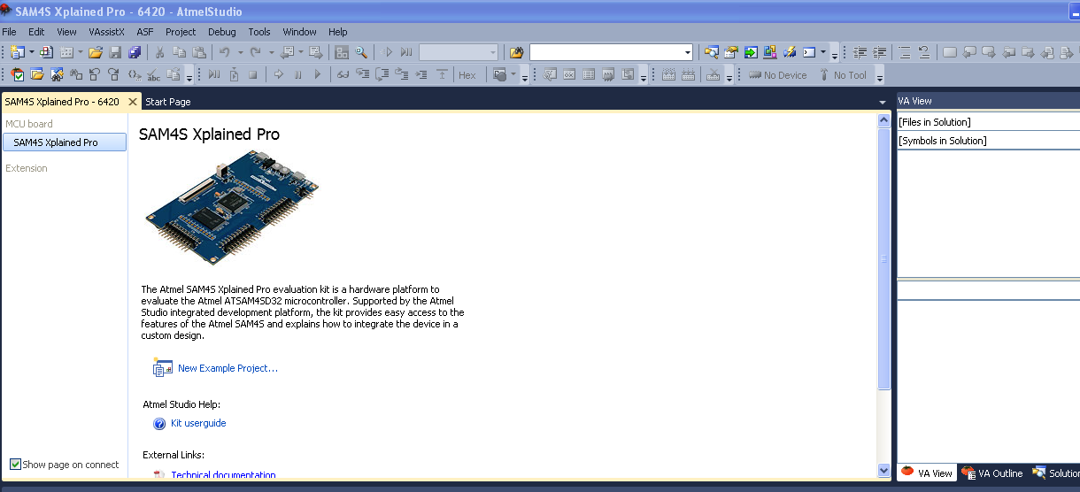

Figure SAM4S Xplained Pro

1. Select New Example Project from this Screen. A new screen will appear. Select Starter Kit Demo and the select desired project name and location. See Figure 11 for reference.
2. Accept all the ASF license agreements.

*Note: This project creation may take some time.*

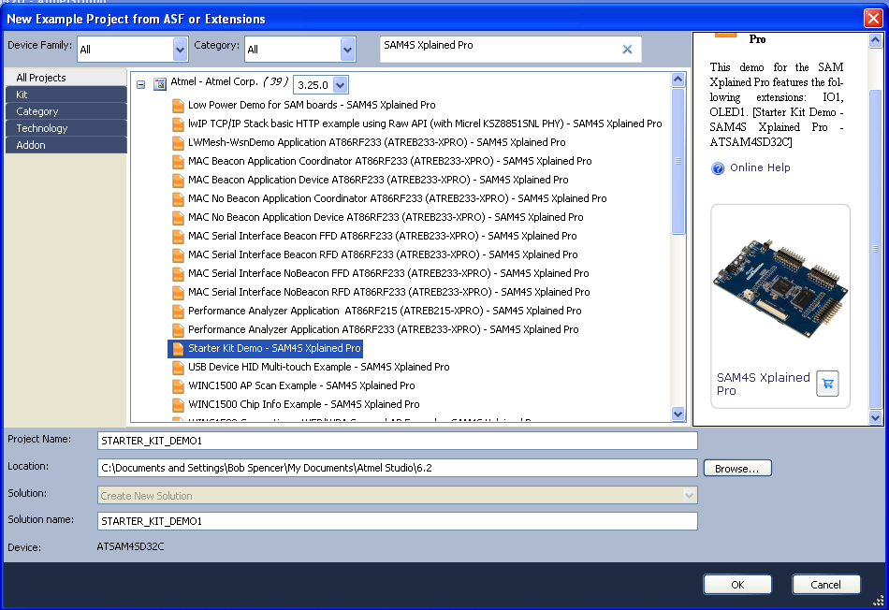

Figure Starter Kit Demo

1. From the Project->Properties menu, a new tab will open. Go to the tools section and select the “EDBG” debugger/programmer. The rest of the inputs can remain as default.
2. Build the example project by select Build->Build Solution. This will compile with no errors.
3. Select Debug->Start Debugging and Break. If the debugger FW (not your project generated FW) is not current, you will be asked to update the debugger FW. See Figure 12 for reference.

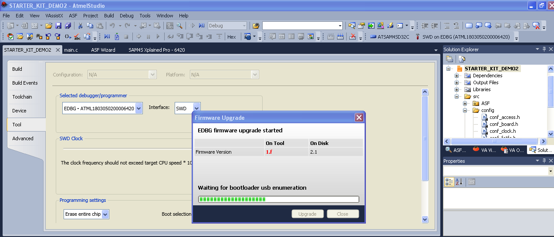

Figure Update Debugger FW

1. Compile and run the project FW

Go to Debug->Start Debugging and Break

This will download and run the generated code.

## Modification to Demo Program

It’s now time to modify the generated source. The objective is to add your name and Company information to the LCD display for 20seconds before executing the demo program. To do this, add the code below before the while(true) loop of main() in main.c

// Clear screen.

ssd1306_clear();

ssd1306_set_page_address(0);

ssd1306_set_column_address(0);

ssd1306_write_text("Robert Spencer");

ssd1306_set_page_address(1);

ssd1306_set_column_address(0);

ssd1306_write_text("Atmel Corporation");

delay_s(20);

The results will be below Figure 13.

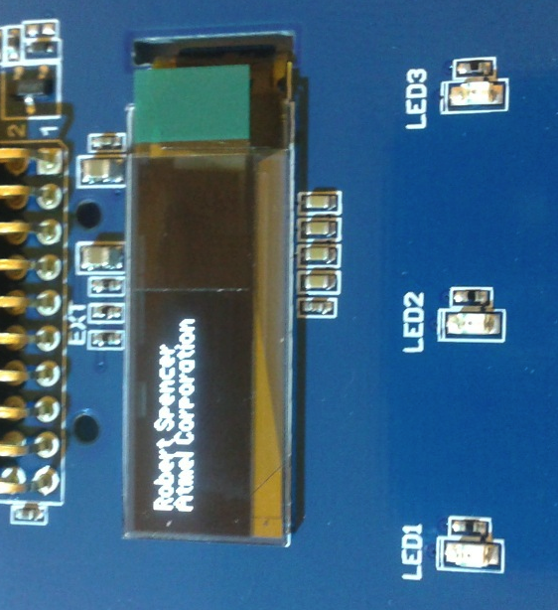

Figure Demo Application Modification

# HARDWARE DEBUGGER

The Atmel Studio has a hardware debugger that allows not only for breakpoints in code execution but for the inspection of memory inside the SAM4SD32C. The tools allow the user to set watch variables as well view sections of memory.

## Break Point

To set a break point, simply left click on the line you where you want to execute the breakpoint. See Figure 14 for reference. To remove the breakpoint, click on the red breakpoint indicator that was previously added.

## Variable Watch

To inspect a variable or piece of memory in the SAM4SD32, the user can add a watch variable. When the application has been loaded to the target and has stopped executing such as at a break point, the user can right click on a variable name and select “Add Watch”. See Figure 14 for reference.

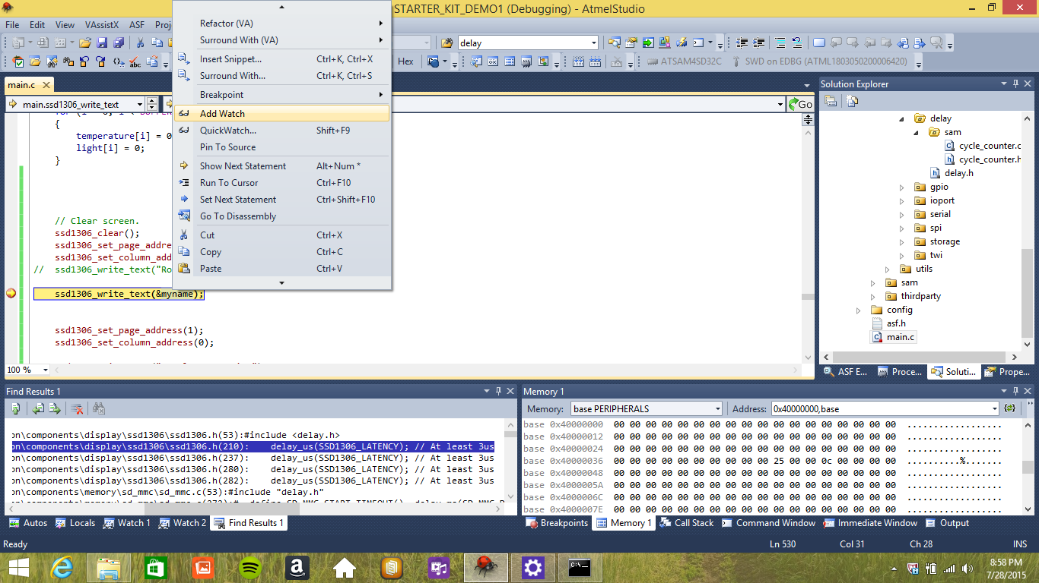

Figure Add Watch Variable

Figure 15 shows the variable during execution in the watch list. This data maybe be changed in real time depending on the type of memory that is listed.

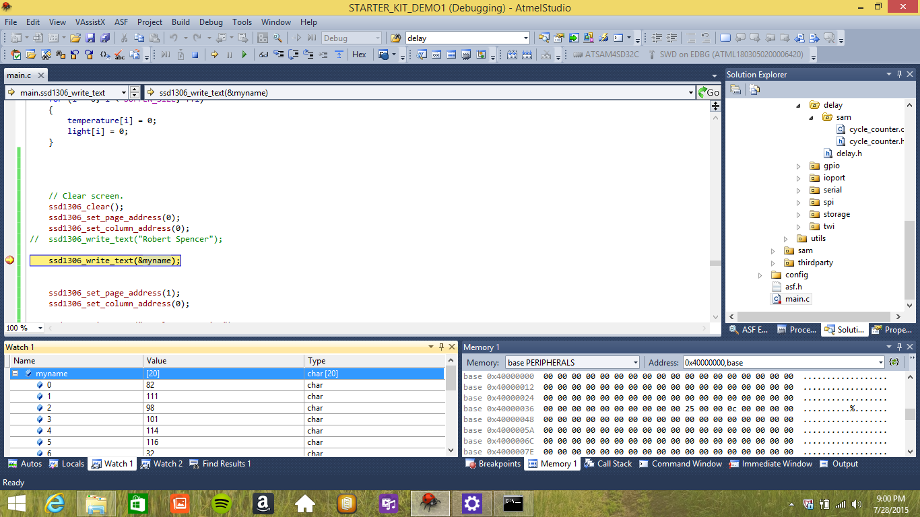

Figure Watch List

# TERMINAL FOR ATMEL STUDIO

Atmel Studio provides a special plug-in for a serial port connection. This tool needs to be downloaded from the Atmel Gallery that is in the Help drop down menu. Once you install this plug-in, restart Atmel Studio for the tool to take affect.

Secondly, the EDBG debugger has a built in virtual com port. Therefore, you can program and debug with only one USB connector.

To access the Terminal Window, go to View -> Terminal Window. Select the virtual COM port, baud rate and hit “Connect”.

An example of the terminal window can be seen in Figure 16.

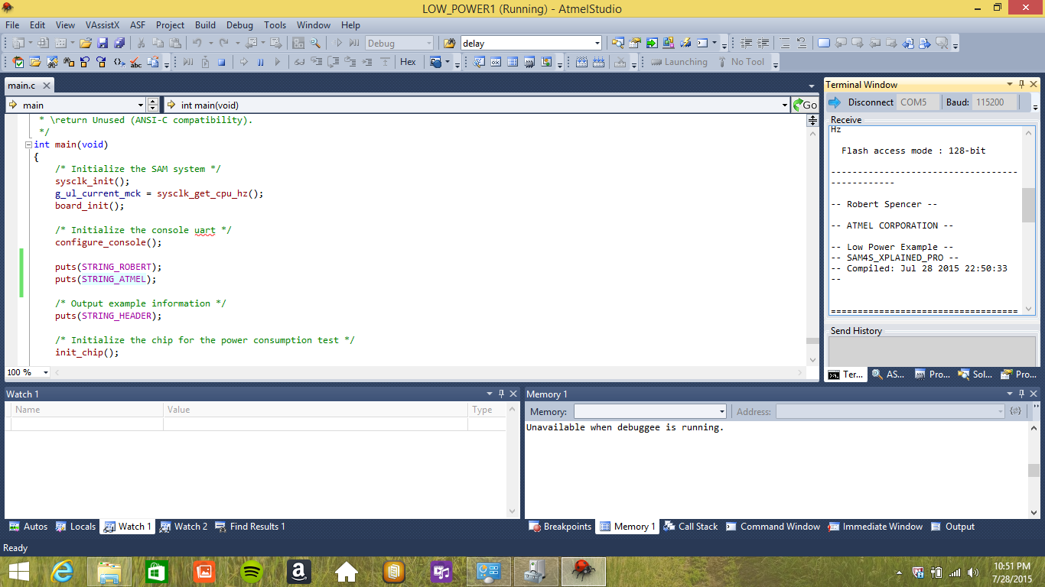

Figure Atmel Terminal Window

# CODE EXERCISES

## Swap Variables

Write a function that will swap to variables without having an intermediate variable. To do this effectively, simply XOR the variables together.

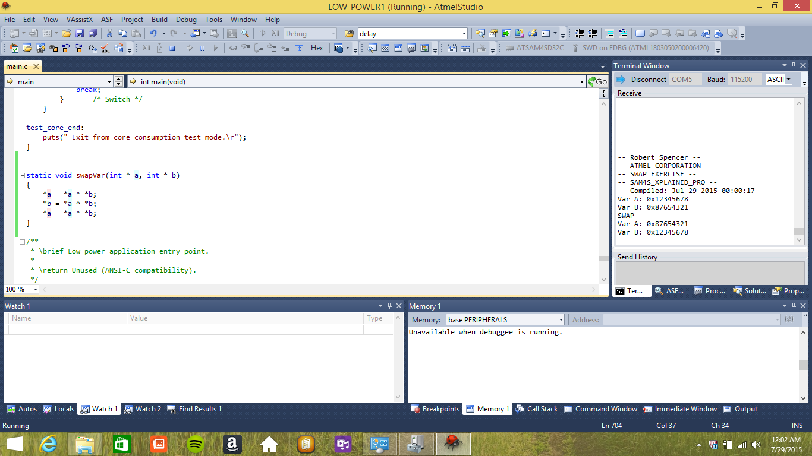

Figure Swap Function

## Count Bits In Byte

Write a function to count the bits in a byte.

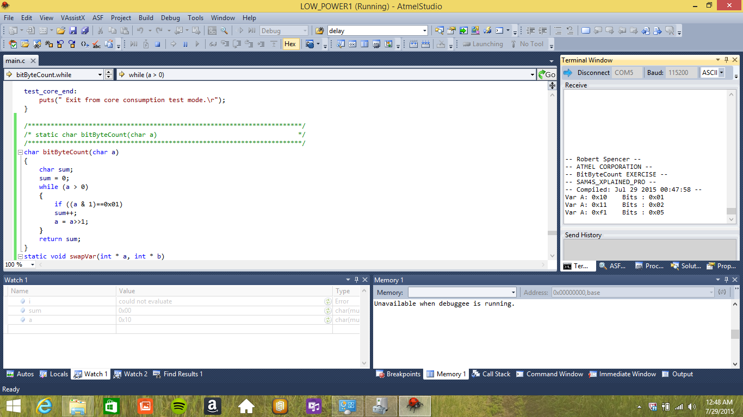

Figure Count Bits Set In Byte

## Nth Bit Test

Write a function that will test the Nth Bit in a 32bit word and return a non-zero value if set.

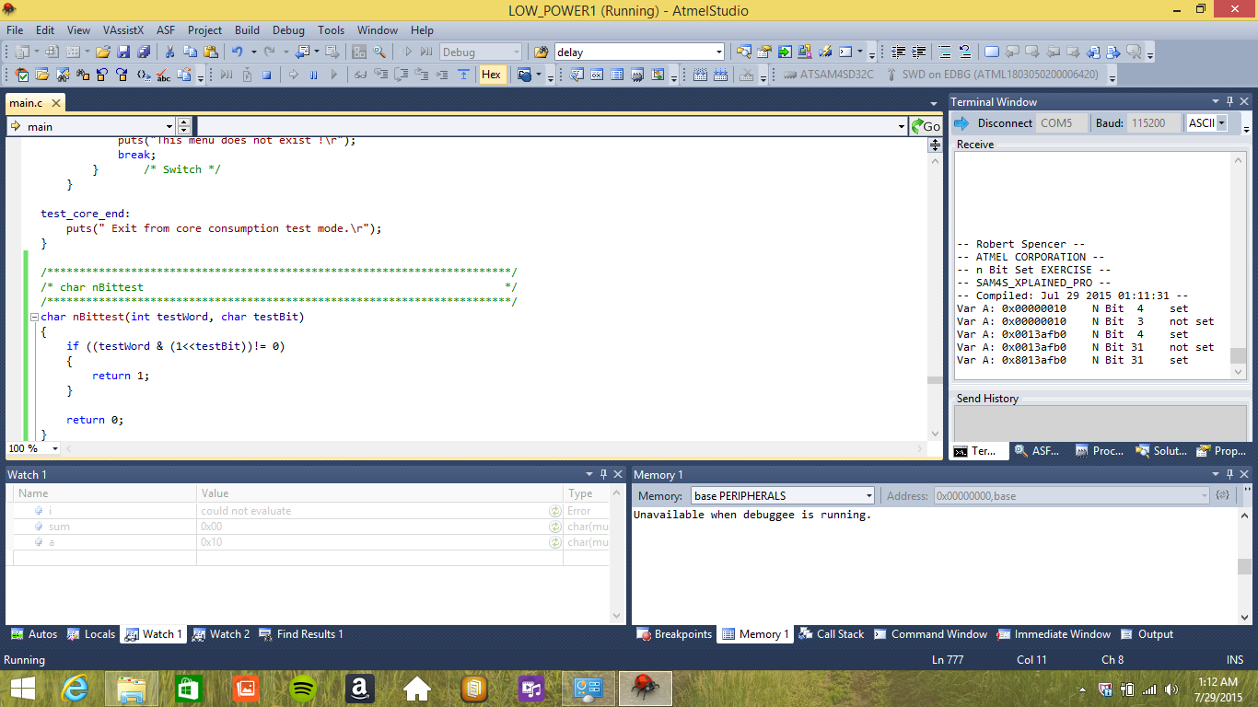

Figure Nth Bit Test

## Extra Credit

Wrote and application that would calculate a SHA256 HASH on any string message. For the string “ATMEL CORPORATION” the following MAC was calculated:

1BEB018FB11FDA6B99F73327D58F7130B979DABDD22CFD66D99E1B5CA9E2651D

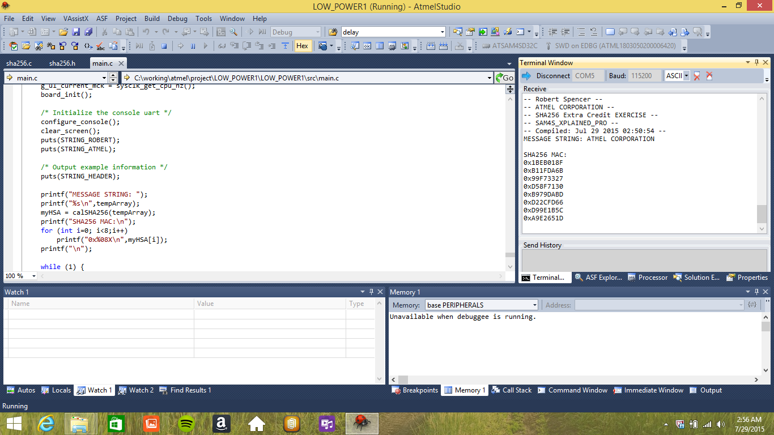

Figure SHA256